

System Requirements Document (SRD)
Project: Retail Investor Stock Trading Application

Prepared by: Aditya Anupam Shukla
Prepared for: Jarvis

Project Sponsor: Jarvis
Client Acceptor: Trevor Doto
Project Manager: Trevor Doto

Change Log
Date | Version | Changes Made
May 25, 2025 | 1 | Initial complete version shared
July 14, 2025 | 2 | Added ERD, Data Requirements, and Acceptance Criteria
July 15, 2025 | 3 | Added System Overview, Updated Use case Diagram

Table of Content
1. Introduction 3
1.1. Executive Summary 3
1.2. Purpose 3
1.3. Intended Audience 3
1.4. Indented Use 3
1.5. Scope 3
1.6. Definitions and Acronyms: 3
2. Overall Description 4
2.1. User Needs: 4
2.2. Assumptions and Dependencies: 4
3. Acceptance Criteria 4
3.1. Functional Acceptance: 4
3.2. Non-Functional Acceptance: 4
3.3. Deployment & Usability: 4
4. User Stories 5
4.1. Onboarding & Authentication 5
4.2. Banking and Funds Management: 5
4.3. Trading: 5
4.4. Portfolio & Performance Tracking: 5
4.5. Notifications & Settings: 5
5. Stakeholders 6
6. Use Case Diagram 7
7. Data Requirements 8
7.1. Core Tables: 8
7.2. Flow Diagram: 9
7.3. ER Diagram: 9
8. System Overview Diagram 10
9. System Features and Requirements 11
9.1. Functional Requirements: 11
9.2. External Interface Requirements: 11
9.3. System Features: 11
9.4. Nonfunctional Requirements: 11

Introduction

Executive Summary
The Retail Investor Stock Trading Application is a mobile-first platform designed to empower individual retail investors by providing secure and intuitive access to stock trading capabilities. Currently, retail clients must engage intermediaries like brokers to conduct trades. This application eliminates that dependency by providing a self-service interface that links with users’ bank accounts, displays real-time stock data, supports order execution, and tracks performance across multiple investment portfolios. Built with scalability and compliance in mind, the application will support future integrations such as cryptocurrency trading, robo-advisory services, and additional financial instruments. The MVP will focus on stock trading with complete transaction transparency, multi-platform access, and bank-level security measures.

Purpose
The purpose of this document is to define the requirements for the development of a mobile-first trading platform that enables retail investors to independently buy and sell securities with ease, security, and transparency. This document sets expectations for scope, features, and technical constraints, and will guide the design, development, testing, and deployment of the system.

Intended Audience
- Business Stakeholders
- Product Managers
- Development Team
- Quality Assurance (QA) Team
- Security & Compliance Officers
- UI/UX Designers
- DevOps/IT Operations
- Legal & Regulatory Advisors

Indented Use
- Serve as the foundation for product development.
- Ensure alignment among cross-functional teams.
- Act as a reference throughout the software lifecycle.
- Define the test plan and validation criteria.

Scope
The software will provide a secure, scalable platform where retail investors can create accounts, link their bank accounts, transfer funds, and trade securities. The MVP will focus on stock trading capabilities with basic features such as account overview, transaction history, and multi-portfolio support. Future releases may expand to include crypto trading, investment suggestions, and global markets.
(Go more in details for the technical team)

Definitions and Acronyms:
- MVP – Minimum Viable Product
- 2FA – Two-Factor Authentication
- UI/UX – User Interface/User Experience
- API – Application Programming Interface
- KYC – Know Your Customer (identity verification)
- GCP – Google Cloud Platform
- Retail Investor – Non-institutional, individual investor
- Portfolio – Collection of investment assets owned by a user

Overall Description

User Needs:
- Ability to self-manage investments with minimal friction
- Secure and quick access to trading and funds
- Real-time insights into performance and transaction history
- An intuitive, mobile-first interface
- Transparent breakdown of transactions and fees

Assumptions and Dependencies:
- The platform will be hosted on Microsoft Azure
- The application will initially use public stock market APIs
- Integration with banking services will follow standard protocols (e.g., OAuth, Plaid)
- Compliance with financial regulations and KYC requirements is mandatory
- Real-time trading execution depends on third-party exchange availability
- Mobile development will be prioritized; web support to follow

Acceptance Criteria

Functional Acceptance:
- Users can register, log in, and complete KYC.
- Users can link bank accounts and transfer funds.
- Users can buy/sell stocks using real-time market data.
- Users can view and manage multiple portfolios.
- Transaction history is available and exportable.

Non-Functional Acceptance:
- Application loads critical pages within 2 seconds.
- App is responsive on both mobile and web.
- Security standards (2FA, data encryption) are implemented.
- Meets compliance standards (PIPEDA, FINTRAC).

Deployment & Usability:
- Successfully deployed on Azure.
- Tested with 100+ users under load.
- Clear user onboarding with minimal friction.
- System is monitored and recoverable (uptime ≥99.9%).

User Stories
This section captures key user stories that define system behaviours from the end-user perspective. These stories will guide the development and validation phases.

Onboarding & Authentication
- US-1: As a new user, I want to register using my email and phone number so that I can create an account on the platform.
- US-2: As a registered user, I want to log in securely using 2FA or biometric login so that I can access my account safely.
- US-3: As a user, I want to complete identity verification (KYC) so that I can comply with regulatory requirements and start trading.

Banking and Funds Management:
- US-4: As a user, I want to link my bank account securely so that I can deposit and withdraw funds.
- US-5: As a user, I want to view my available balance and transaction history so that I can track my financial activities.
- US-6: As a user, I want to receive a confirmation when a fund transfer is successful so that I have a clear audit trail.

Trading:
- US-7: As a user, I want to search and view stock details so that I can decide whether to invest.
- US-8: As a user, I want to place buy or sell orders with options for market or limit orders so that I have control over how trades are executed.
- US-9: As a user, I want to receive real-time updates about my orders so that I can monitor my trading activity.

Portfolio & Performance Tracking:
- US-10: As a user, I want to view a dashboard showing my investments, gains/losses, and performance trends so that I can assess my financial progress.
- US-11: As a user, I want to create and manage multiple portfolios so that I can diversify my investments.
- US-12: As a user, I want to export my portfolio and transactions in CSV or PDF format so that I can analyse them offline or share with my accountant.

Notifications & Settings:
- US-13: As a user, I want to receive push/email notifications for critical updates (e.g., order execution, fund deposit) so that I stay informed.
- US-14: As a user, I want to customize notification preferences so that I only receive alerts relevant to me.
- US-15: As a user, I want to update my account settings including password and 2FA preferences so that I can maintain control over my security.

Stakeholders
# | Stakeholder | Type | Role/Responsibility
1 | Retail Investors (End Users) | Primary | Use the app to trade stocks, manage portfolios, and track performance
2 | Jarvis | Internal/Primary | Project sponsor and initiator; provides funding and vision
3 | Trevor Doto | Internal/Primary | Project Manager & Client Acceptor; oversees delivery and approves deliverables
4 | Product Managers | Internal | Define product roadmap, prioritize features, and align goals with user needs
5 | Development Team | Internal | Build, integrate, and maintain the system (mobile, frontend, backend)
6 | UI/UX Designers | Internal | Design intuitive, mobile-first user interfaces
7 | Quality Assurance (QA) Team | Internal | Test the system and ensure it meets functional and non-functional requirements
8 | DevOps / IT Operations | Internal | Manage deployment, infrastructure (e.g., GCP), and ensure uptime
9 | Security & Compliance Officers | Internal | Enforce data security, regulatory compliance (KYC, PIPEDA, FINTRAC)
10 | Legal & Regulatory Advisors | External Support | Advise on legal requirements and ensure regional regulatory compliance
11 | Banking API Providers (e.g., Plaid) | External Technical | Facilitate secure linking of user bank accounts and fund transfers
12 | Market Data Providers (e.g., IEX Cloud) | External Technical | Supply real-time stock prices and trading data
13 | KYC Verification Providers | External Technical | Provide services to validate user identity securely and in compliance

Use Case Diagram
Below is a visual representation in UML (Unified Modelling Language) that depicts the interactions between a system and its users (or other external systems), showing how the system is used and what it does from the user's perspective.
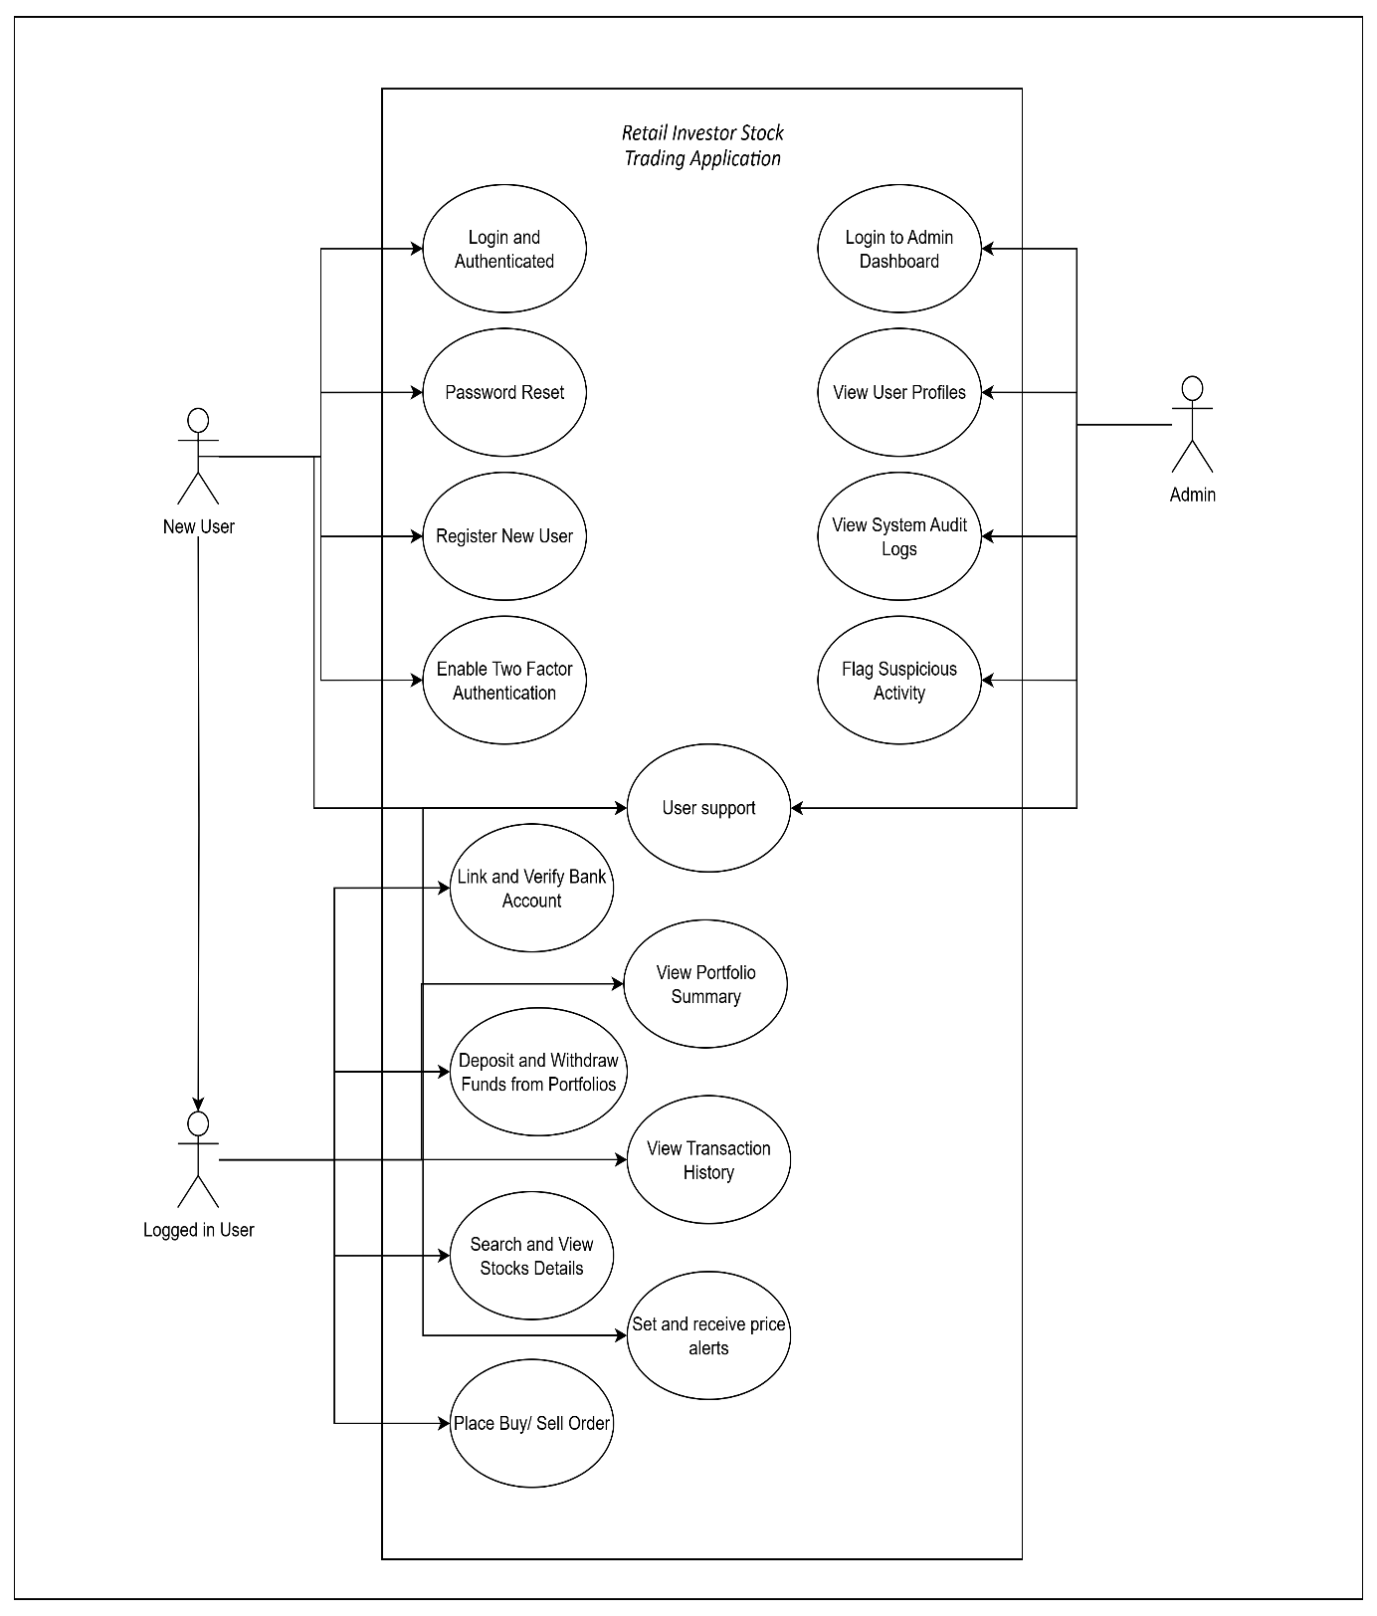

Data Requirements
This section describes the logical data model and key database tables:

Core Tables:
- Users
Column | Type | Notes
user_id | UUID / INT (PK) | Primary Key
email | VARCHAR
password_hash | TEXT
2fa_enabled | BOOLEAN
kyc_status | VARCHAR

- Portfolios
Column | Type | Notes
portfolio_id | UUID / INT (PK) | Primary Key
user_id | UUID / INT (FK) | Foreign Key → Users(user_id)
name | VARCHAR | Portfolio name
created_at | TIMESTAMP | Creation time

- Holdings
Column | Type | Notes
holding_id | UUID / INT (PK) | Primary Key
portfolio_id | UUID / INT (FK) | Foreign Key → Portfolios(portfolio_id)
stock_symbol | VARCHAR
quantity | INT
avg_price | DECIMAL

- Transactions
Column | Type | Notes
transaction_id | UUID / INT (PK) | Primary Key
user_id | UUID / INT (FK) | Foreign Key → Users(user_id)
type | VARCHAR | deposit / withdrawal / trade
amount | DECIMAL
timestamp | TIMESTAMP
status | VARCHAR

- StockOrders
Column | Type | Notes
order_id | UUID / INT (PK) | Primary Key
portfolio_id | UUID / INT (FK) | Foreign Key → Portfolios(portfolio_id)
stock_symbol | VARCHAR
order_type | VARCHAR | buy / sell / limit
price | DECIMAL
quantity | INT
status | VARCHAR | pending / filled / canceled

- BankAccounts
Column | Type | Notes
bank_id | UUID / INT (PK) | Primary Key
user_id | UUID / INT (FK) | Foreign Key → Users(user_id)
provider | VARCHAR | e.g., Plaid
last_synced | TIMESTAMP
account_status | VARCHAR | active / inactive / error

Flow Diagram:
Below is the Flow diagram illustrating the flow of data between tables/views and columns in a data warehouse by generating a concise diagram.
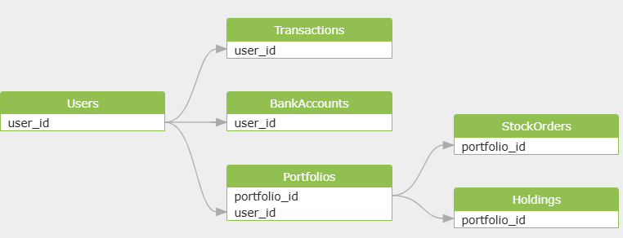

ER Diagram:
Below is the Entity-Relationship Diagram illustrating the relationships between the core entities in the data model:
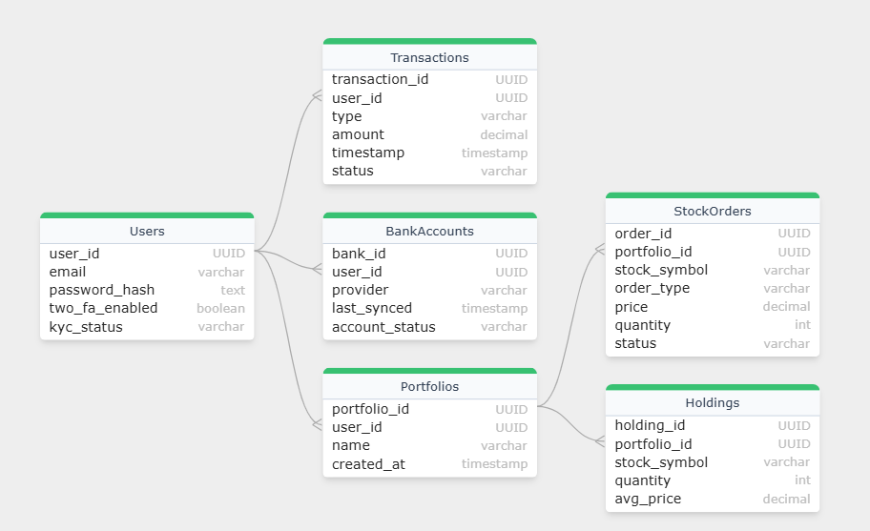

System Overview Diagram
This diagram outlines the major components of the trading application and their interactions
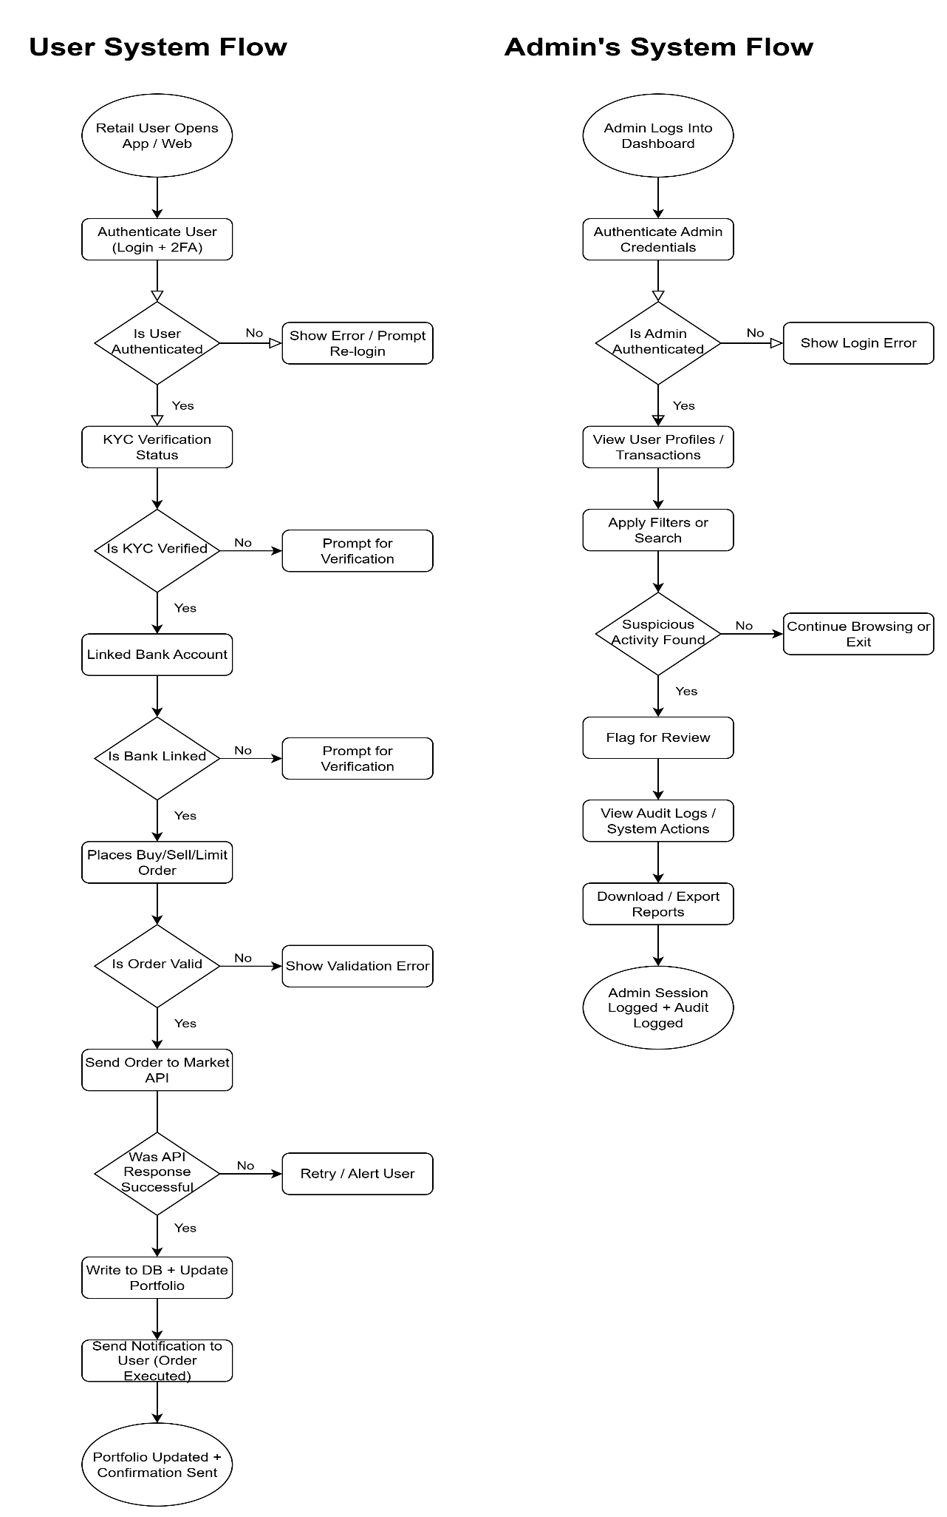

System Features and Requirements

Functional Requirements:
- FR-1: Users can create, view, and manage personal accounts
- FR-2: Secure login with 2FA and biometric options
- FR-3: Users can link and verify bank accounts
- FR-4: Ability to transfer funds to and from bank accounts
- FR-5: Users can buy/sell stocks and set trade parameters (e.g., limit, market)
- FR-6: Track and display investment performance and gains/losses
- FR-7: View, download, and share transaction history
- FR-8: Users can manage multiple investment portfolios
- FR-9: Application must validate user eligibility and identity via KYC
- FR-10: Notification system for login, transaction status, and system updates

External Interface Requirements:
- User Interface:
  - Mobile-first design with responsive layout for Android/ iOS
  - Tabs for Portfolio, Trade, History, Funds, and Settings
- API Interfaces:
  - Integration with public stock data APIs (e.g., Alpha Vantage, IEX Cloud)
  - Banking API for account linkage and fund transfers
- Authentication:
  - Support for 2FA, OAuth2.0, and biometric login
- Export Features:
  - PDF or CSV download options for reports and transactions

System Features:
- Modular portfolio management
- Real-time price tracking and order placement
- Secure user onboarding and KYC verification
- Notification and alert system
- Admin dashboard for internal monitoring (Phase 2)
- Logging for audit trail and activity tracking

Nonfunctional Requirements:
- Performance: App should load main screens within 2 seconds under normal conditions
- Scalability: Must support 150,000+ users with ability to scale to 500,000
- Availability: 99.9% uptime requirement
- Security:
  - End-to-end encryption for data in transit and at rest
  - Role-based access control
  - Compliance with PIPEDA/FINTRAC (Canada) or relevant regional standards
- Maintainability: Modular architecture to ease updates
- Portability: Must work across iOS, Android, and major browsers for web version
- Usability:
  - Easy navigation, minimal clicks to complete key actions
  - User onboarding should be completed within 5 minutes

